Netflix A/B Testing Demo

|  |  |
| --- | --- |
| **Summary** | Iwwwwwwwf |
| **URL** | Netflix A/B Testing |
| **Category** | Data Science |
| **Environment** | Python, Statistics, |
| **Status** | Published |
| **Feedback Link** | https://github.com/ |
| **Author** | Vividh Talesara |
| **Author LDAP** | vividh |
| **Analytics Account** | vividhtalesara |

Introduction

What makes a web app, a Progressive Web App?

Fast & Reliable

Installable

Mobile & Desktop

What you’ll build

What you’ll learn

What you’ll need

Getting set up

Get a key for the Dark Sky API

Verify your API key is working properly

Get the code

Strongly Recommended: Use Glitch to import the repo

Alternative: Download code & work locally

Establish a baseline

What’s our starting point?

Audit with Lighthouse

Let’s run Lighthouse

The Progressive Web App Audit

Add a web app manifest

Create the web app manifest

Add a link to the web app manifest

public/index.html

DevTools Detour

Add iOS meta tags & icons

public/index.html

Bonus: Easy Lighthouse fixes

Set the meta description

public/index.html

Set the address bar theme color

public/index.html

Verify changes with Lighthouse

Provide a basic offline experience

Service workers to the rescue

Register the service worker

public/index.html

Precache offline page

public/service-worker.js

public/service-worker.js

DevTools Detour

Clean-up old offline pages

public/service-worker.js

DevTools Detour

Handle failed network requests

public/service-worker.js

DevTools Detour

Tips for testing service workers

Use DevTools

Start Fresh

Verify changes with Lighthouse

Provide a full offline experience

Service worker life cycle

install event

activate event

fetch event

Updating a service worker

Choosing the right caching strategy

Caching static resources

Caching the app data

Update app logic

public/scripts/app.js

public/scripts/app.js

public/scripts/app.js

Pre-cache our app resources

public/service-worker.js

public/service-worker.js

Update the activate event handler

public/service-worker.js

Update the fetch event handler

public/service-worker.js

Try it out

Verify changes with Lighthouse

Add install experience

Audit with Lighthouse

Add install.js to index.html

public/index.html

Listen for beforeinstallprompt event

public/scripts/install.js

Save event and show install button

public/scripts/install.js

Show the prompt / hide the button

public/scripts/install.js

Log the results

public/scripts/install.js

Log all install events

public/scripts/install.js

public/scripts/install.js

Update the service worker

Try it out

Verify the install button is visible

Verify the install button works

Verify iOS installation works properly

Bonus: Detecting if your app is launched from the home screen

Bonus: Uninstalling your PWA

Android

ChromeOS

macOS and Windows

Congratulations

What’s next?

Further reading

Reference docs

# What is Netflix?

**Last Updated:** 12-06-2019

## Netflix Wiki

Netflix, Inc. is an American media-services provider and production company headquartered in Los Gatos, California, founded in 1997 by Reed Hastings and Marc Randolph in Scotts Valley, California.



### What Netflix Does?

Netflix is a streaming service that allows our members to watch a wide variety of [award-winning TV shows, movies, documentaries, and more](https://media.netflix.com/) on [thousands of internet-connected devices](http://devices.netflix.com/). With Netflix, you can enjoy unlimited ad-free viewing of our content. There's always something new to discover, and more TV shows and movies are added every month!

If you're already a member and would like to learn more about using Netflix, visit [Getting started with Netflix](https://help.netflix.com/en/node/102377).

## Netflix Products & Services

* In [over 190 countries](https://help.netflix.com/en/node/14164), Netflix members get instant access to great content. Netflix has an extensive global content library featuring [award-winning Netflix originals, feature films, documentaries, TV shows, and more](https://media.netflix.com/). Netflix content will vary by region, and may change over time.
* The more you watch, the better Netflix gets at recommending TV shows and movies you’ll love.
* You can play, pause, and resume watching without ads or commitments.
* Plus, you can [download your favorite shows](https://help.netflix.com/en/node/54816) to your iOS or Android mobile device, or Windows 10 app. With downloads, you can watch while you're on the go and without an internet connection. Go ahead, binge a little!



|  |
| --- |
| Link : <https://www.netflix.com/>  Source: <https://help.netflix.com/en/node/412> |

# A/B Test Demo

Demo: Python

## Problem Statement

We will be working to understand the results of an A/B test run by an e-commerce website (In this case Netflix). My goal is to help Netflix understand if they should implement the new page, keep the old page, or perhaps run the experiment longer to make their decision.

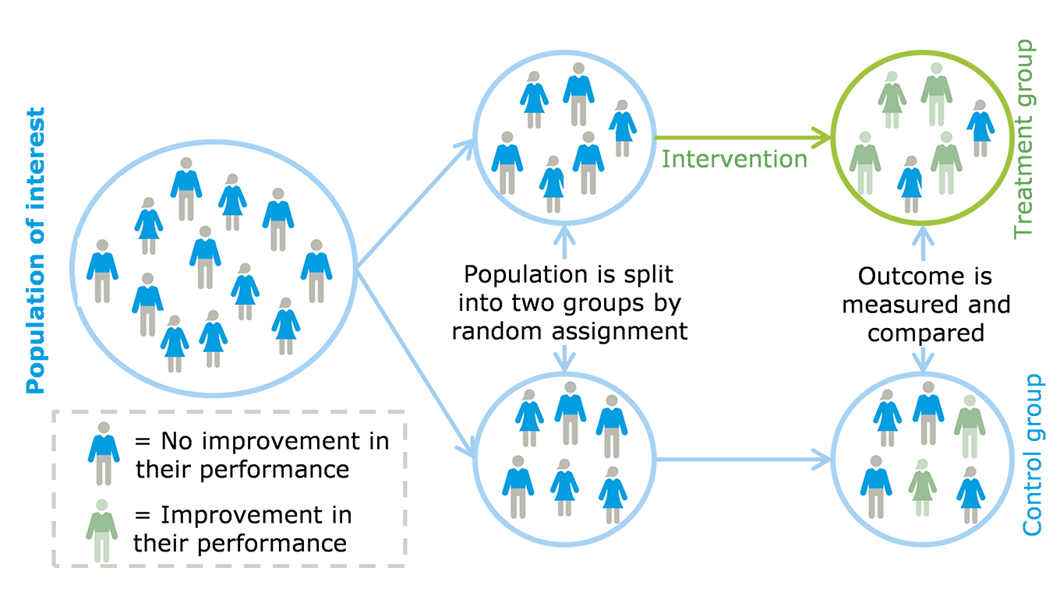

|  |
| --- |
| **Data Source:** <https://www.kaggle.com/zhangluyuan/ab-testing#ab_data.csv> |

## Code Starts Here!

#### Part I - Wrangle data & Exploratory Data Analysis

#### Part II - A/B Test

#### Part III - Regression

### Exploratory Data Analysis

Required Libraries :

**✅ PASSED:** import **pandas** as pd

**✅ PASSED:** import **numpy** as np

**✅ PASSED:** import **random**

**✅ PASSED:** import **matplotlib**.pyplot as plt

**✅ PASSED:** %matplotlib inline

**✅ PASSED:** from sklearn.linear_model import **LogisticRegression**

**✅ PASSED:** import statsmodels.api as **sm**

**✅ PASSED:** from scipy.stats import **norm**

How does data looks like -

|  |
| --- |
| df = pd.read_csv("data/ab_data.csv")  df.head() |

|  |
| --- |
| **Output:** |

Perform a Groupby to check how population is distributed among ‘old_landing_page’ and ‘new_landing_page’ -

|  |
| --- |
| df.user_id.nunique()  df.groupby(['group','landing_page']).count()['converted'] |

|  |
| --- |
| **Output:** |

Calculating conversion rate in different scenarios and making sure data is distributed equally -

|  |
| --- |
| # Calculate the probability of an individual converting regardless of the page they receive  all_conv = "%.4f" % (df.converted.sum() / df.converted.count())  All_conv   * The probability of an individual converting regardless of the page they receive is ***11.97%***   # Calculate the probability the individual was in the control group to convert  control_conv = df.query("group == 'control'")['converted'].sum() / df.query("group == 'control'")['converted'].count()  "%.4f" % control_conv   * The probability they converted based on control group is ***12.03%***   # Calculate the probability the individual was in the treatment group to convert  treat_conv = df.query("group == 'treatment'")['converted'].sum() / df.query("group == 'treatment'")['converted'].count()  "%.4f" % treat_conv   * The probability they converted based on treatment group is ***11.88%***   # Calculate the probability that an individual received the new page  p_n = df.query('landing_page == "new_page"').user_id.nunique() / df2.user_id.nunique()  "%.4f" % p_n   * The probability that an individual received the new page is ***50.01%*** |

|  |
| --- |
| **Probability Results:** *It seems to be that there is insufficient evidence to say that the new treatment page leads to more conversions than the control page. The difference of probability between control (12.03%) and treatment groups (11.88%) is tiny, especially when we compare them with the probability of individual conversion (11.97%)* |

# A/B Testing

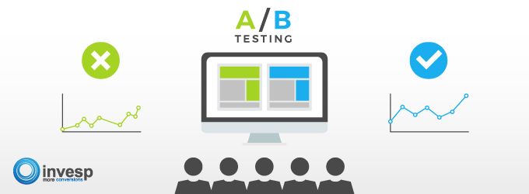

Since we do not have sufficient evidence to say that the new treatment page leads to more conversions than the control page with probability tests, I will run a hypothesis test continuously as each observation was observed with the timestamp associated with each event.

1. We will consider making the decision only based on all the data provided. Further, we want to assume that the old page is better unless the new page proves to be definitely better at a Type I error rate of 5%. The null and alternative hypotheses follow below:

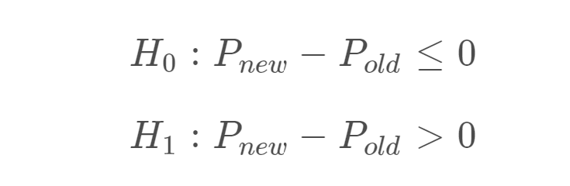

1. I will assume under the null hypothesis, Pnew(treat_conv) and Pold(control_conv) both have "true" success rates equal to the converted success rate regardless of page -- that is Pnew and Pold are equal. Furthermore, I will assume they are equal to the converted rate in ab_data.csv regardless of the page. I will use a sample size for each page equal to the ones in ab_data.csv. I will perform the sampling distribution for the difference in **converted** between the two pages over 50,000 iterations of calculating an estimate from the null.

Let’s see what are our n_new, n_old -

|  |
| --- |
| n_new = df2.query('landing_page == "new_page" ').count()[0]   * New page count : 144314   n_old = df2.query('landing_page == "old_page" ').count()[0]   * Old page count : 144226 |

Simulate 20,000 treat_conv - control_conv values with random binomial

|  |
| --- |
| new_converted_simulation = np.random.binomial(n_new, treat_conv, 20000)/n_new  old_converted_simulation = np.random.binomial(n_old, control_conv, 20000)/n_old  p_diffs = new_converted_simulation - old_converted_simulation |

|  |
| --- |
| **Output:** array([-0.00344107, -0.0045162 , 0.00204104, ..., -0.00280359,  -0.0012587 , -0.00212381]) |

Plot the p_diff

|  |
| --- |
| p_diffs = np.array(p_diffs)  plt.hist(p_diffs) |

|  |
| --- |
| **Output:** |

Now let’s calculate the actual Difference Observed -

|  |
| --- |
| new_convert = df2.query('converted == 1 and landing_page == "new_page"').count()[0]/n_new  old_convert = df2.query('converted == 1 and landing_page == "old_page"').count()[0]/n_old  obs_diff = new_convert - old_convert  Obs_diff   * Observed difference : -0.0015631577894657384 |

Check as well as Plot the proportion of the p_diffs are greater than the actual difference observed in ab_data.

|  |
| --- |
| null_vals = np.random.normal(0, p_diffs.std(), p_diffs.size)  plt.hist(null_vals);  plt.axvline(x=obs_diff, color='red')  (null_vals > obs_diff).mean() |

|  |
| --- |
| **Output:**    **Output : 0.9022** |

|  |
| --- |
| **Sample Distribution Analysis Results:**   1. The proportion of the conversion rate differences were greater than the actual observed difference. The p-value is extremely large (90%) than the type I error rate (5%).That means we fail to reject the null hypothesis. 2. According to Wikipedia, p-value is the probability for a given statistical model that, when the null hypothesis is true, the statistical summary (such as the sample mean difference between two compared groups) would be the same as or of greater magnitude than the actual observed results. 3. When the p-value is low (in this project less than 5%), it suggests that the null hypothesis is not true, and we need to consider the alternative hypothesis. Finally, the p-value of 90% indicates that the actual page should be maintained. |

3. Now, I will use stats.proportions_ztest to compute my test statistic and p-value for evaluating if there is a statistically significance difference in conversion rates of the new page and the conversion rates of the old page.

First, I will calculate the number of conversions for each page, as well as the number of individuals who received each page. The n_old and n_new refer the the number of rows associated with the old page and new pages, respectively.

|  |
| --- |
| convert_old = df2.query('converted == 1 and landing_page == "old_page"').count()[0]  convert_new = df2.query('converted == 1 and landing_page == "new_page"').count()[0]  n_old = df2.query('landing_page == "old_page" ').count()[0]  n_new = df2.query('landing_page == "new_page" ').count()[0]  convert_old,convert_new,n_old,n_new |

|  |
| --- |
| **Output : (17349, 17134, 144226, 144314)** |

Calculate Zscore and Pvalue

|  |
| --- |
| z_score, p_value = sm.stats.proportions_ztest(np.array([convert_new,convert_old]), np.array([n_new,n_old]), alternative = 'larger')  z_score, p_value |

|  |
| --- |
| **Output : (-1.2942367891190543, 0.9022081785605929)** |

Calculate how significant our z-score is and what our critical value at 96% confidence is

|  |
| --- |
| # Tells us how significant our z-score is  norm.cdf(z_score)  # Tells us what our critical value at 96% confidence is  norm.ppf(1-(0.05/2)) |

|  |
| --- |
| **Output :**  norm.cdf(z_score) - **0.09779182143940718**  norm.ppf(1-(0.05/2)) - **1.959963984540054** |

|  |
| --- |
| **Z-test Results:**  Since the z-score of 1.29 does not exceed the critical value of 1.96, we fail to reject the null hypothesis. The conversion rates of the old page is greater than or equal to the conversion rates of the new. Moreover, there was not a significant difference between the conversion rates of the new page and the conversion rates of the old page (>0.15%). |

# Regression Approach

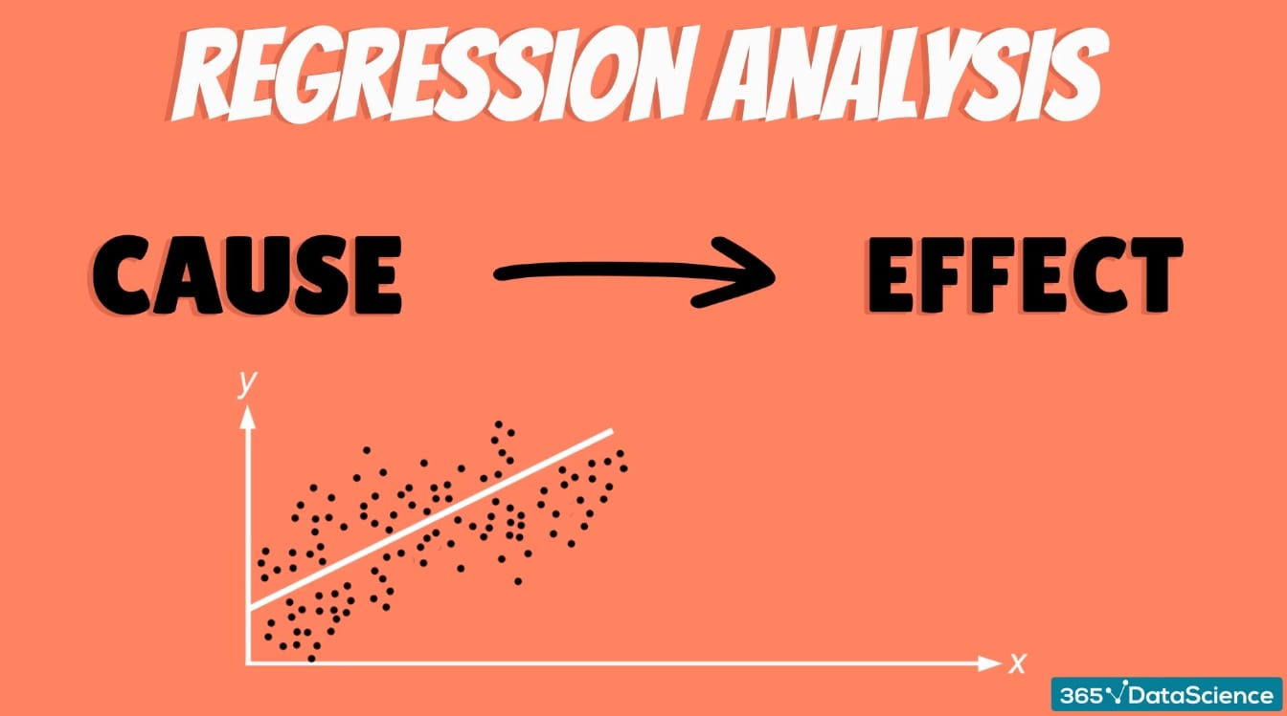

In this final part, we will confirm that the result achieved in the previous A/B test can also be achieved by performing logistic regression. we will use **statsmodels** to fit the regression model to see if there is a significant difference in conversion based on which page a customer receives.

Creating Intercept and Dummy Columns -

|  |
| --- |
| df2['intercept'] = 1  df2[['ab_page','old_page']] = pd.get_dummies(df2['landing_page'])  df2 = df2.drop('old_page', axis = 1) |

|  |
| --- |
| **Output :** |

Create & Fit the Model -

|  |
| --- |
| #Create a model  log = sm.Logit(df2['converted'], df2[['intercept', 'ab_page']])  results = log.fit()  results.summary() |

|  |
| --- |
| **Output :** |

|  |
| --- |
| **Regression Analysis Results:**   1. The p-value associated with ab_page is 0.19 and the p-value in Part II (A/B test) was 0.90. So, in both cases, we fail to reject the null hypothesis because these two p-values are greater than 0.05(Type Error I). 2. The difference lies in what each test assumes for their hypothesis. In Part II, the hypothesis is to analyze if the old page is better unless the new page proves to be definitely greater at a Type I error rate of 5%. In other words,we were concerned with which page had a higher conversion rate, so a one-tailed test. While in the Part III hypothesis, there is a significant difference in conversion based on which page a customer receives.   The nature of a regression test is not concerned with which had a positive or negative change, specifically. It is concerned with if the condition had any effect at all, so a two-tailed test. |

# Incorporate A/B Testing - Netflix

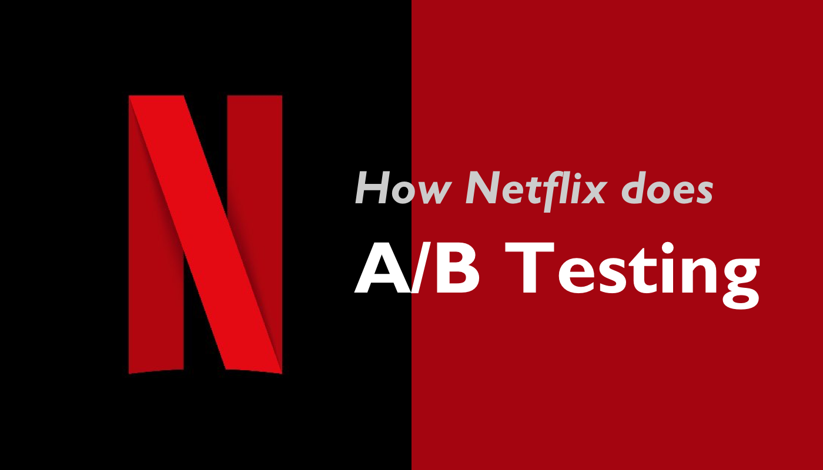

## 

## How’s the Typical workflow looks like?

In this example, we’re running a hypothetical A/B test with the purpose of finding the image which results in the greatest number of members watching a specific title. Each cell represents a candidate image. In the diagram we’re also assuming a call flow from a Netflix App running on a PS4, although the same flow is valid for most of our Device Apps.

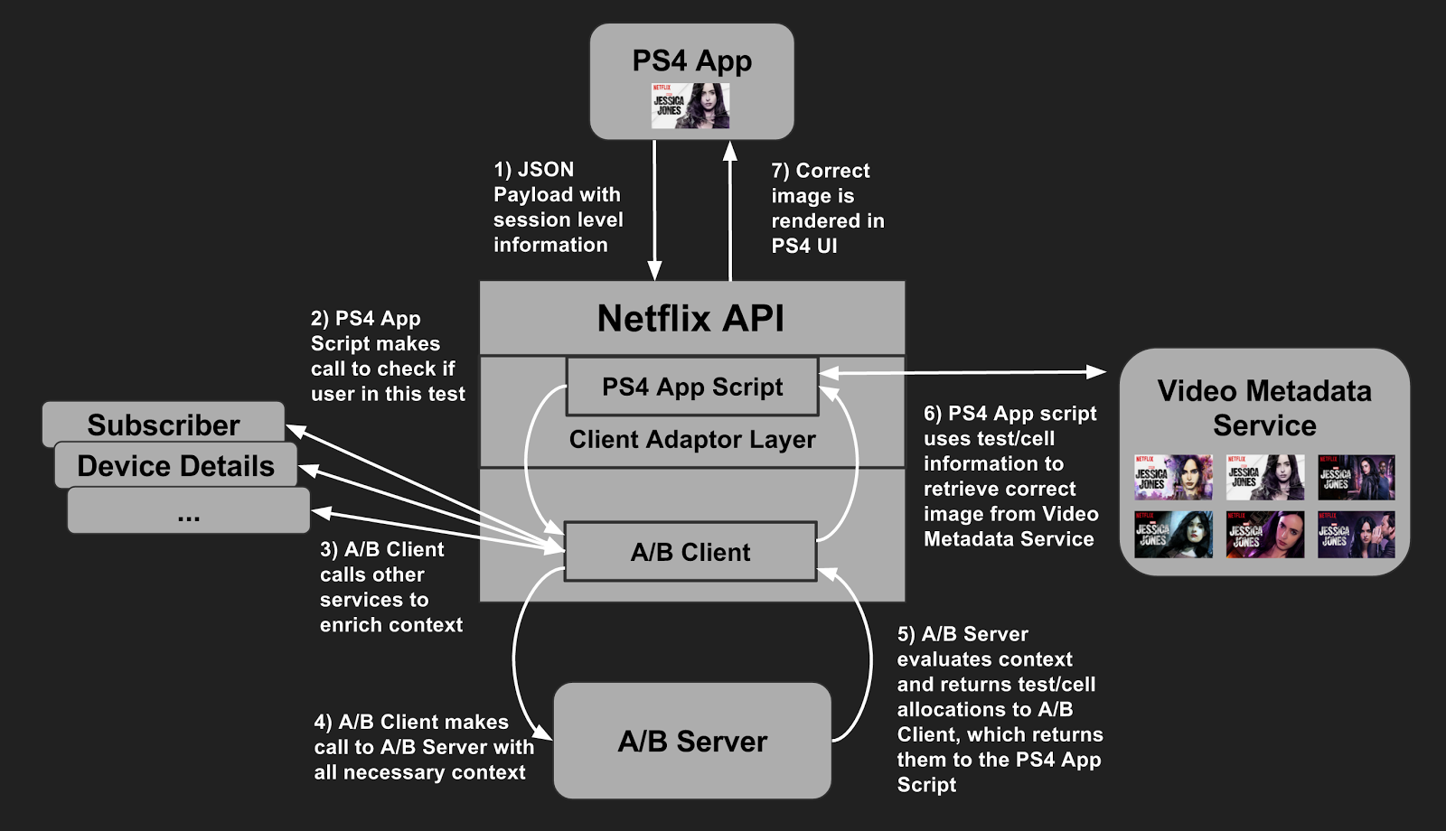

1. The Netflix PS4 App calls the Netflix API. As part of this call, it delivers a JSON payload containing session level information related to the user and their device.
2. The call is processed in a script written by the PS4 App team. This script runs in the Client Adaptor Layer of the Netflix API, where each Client App team adds scripts relevant to their app. Each of these scripts come complete with their own distinct REST endpoints. This allows the Netflix API to own functionality common to most apps, while giving each app control over logic specific to them. The PS4 App Script now calls the A/B Client, a library our team maintains, and which is packaged within the Netflix API. This library allows for communication with our backend servers as well as other internal Netflix services.
3. The A/B Client calls a set of other services to gather additional context about the member and the device.
4. The A/B Client then calls the A/B Server for evaluation, passing along all the context available to it.
5. In the evaluation phase:  
   a) The A/B Server retrieves all test/cell combinations to which this member is already allocated.  
   b) For tests utilizing the batch allocation approach, the allocations are already known at this stage.  
   c) For tests utilizing real-time allocation, the A/B Server evaluates the context to see if the member should be allocated to any additional tests. If so, they are allocated.  
   d) Once all evaluations and allocations are complete, the A/B Server passes the complete set of tests and cells to the A/B Client, which in turn passes them to the PS4 App Script. Note that the PS4 App has no idea if the user has been in a given test for weeks or the last few microseconds. It doesn’t need to know or care about this.
6. Given the test/cell combinations returned to it, the PS4 App Script now acts on any tests applicable to the current client request. In our example, it will use this information to select the appropriate piece of art associated with the title it needs to display, which is returned by the service which owns this title metadata. Note that the Experimentation Platform does not actually control this behavior: doing so is up to the service which actually implements each experience within a given test.
7. The PS4 App Script (through the Netflix API) tells the PS4 App which image to display, along with all the other operations the PS4 App must conduct in order to correctly render the UI

## Example 1 : Video Play Button Delay Time

Suppose you’re running a new [video encoding test](https://medium.com/netflix-techblog/more-efficient-mobile-encodes-for-netflix-downloads-625d7b082909) and theorize that the two new encodes should reduce play delay, a metric describing how long it takes for a video to play after you press the start button. You can look at [ABlaze](https://medium.com/netflix-techblog/its-all-a-bout-testing-the-netflix-experimentation-platform-4e1ca458c15) (our centralized A/B testing platform) and take a quick look at how it’s performing.

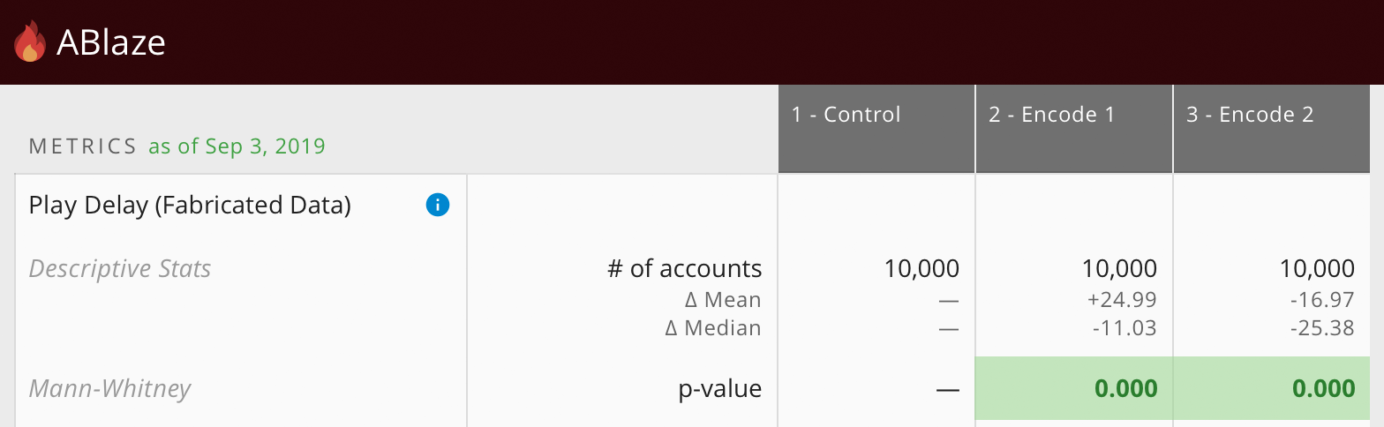

You notice that the first new encode (Cell 2 — Encode 1) increased the mean of the play delay but decreased the median!

After recreating the dataset, you can plot the raw numbers and perform custom analyses to understand the distribution of the data across test cells.

With our new platform for experimentation analysis, it’s easy for scientists to perfectly recreate analyses on their laptops in a notebook. They can then choose from a library of statistics and visualizations or contribute their own to get a deeper understanding of the metrics.

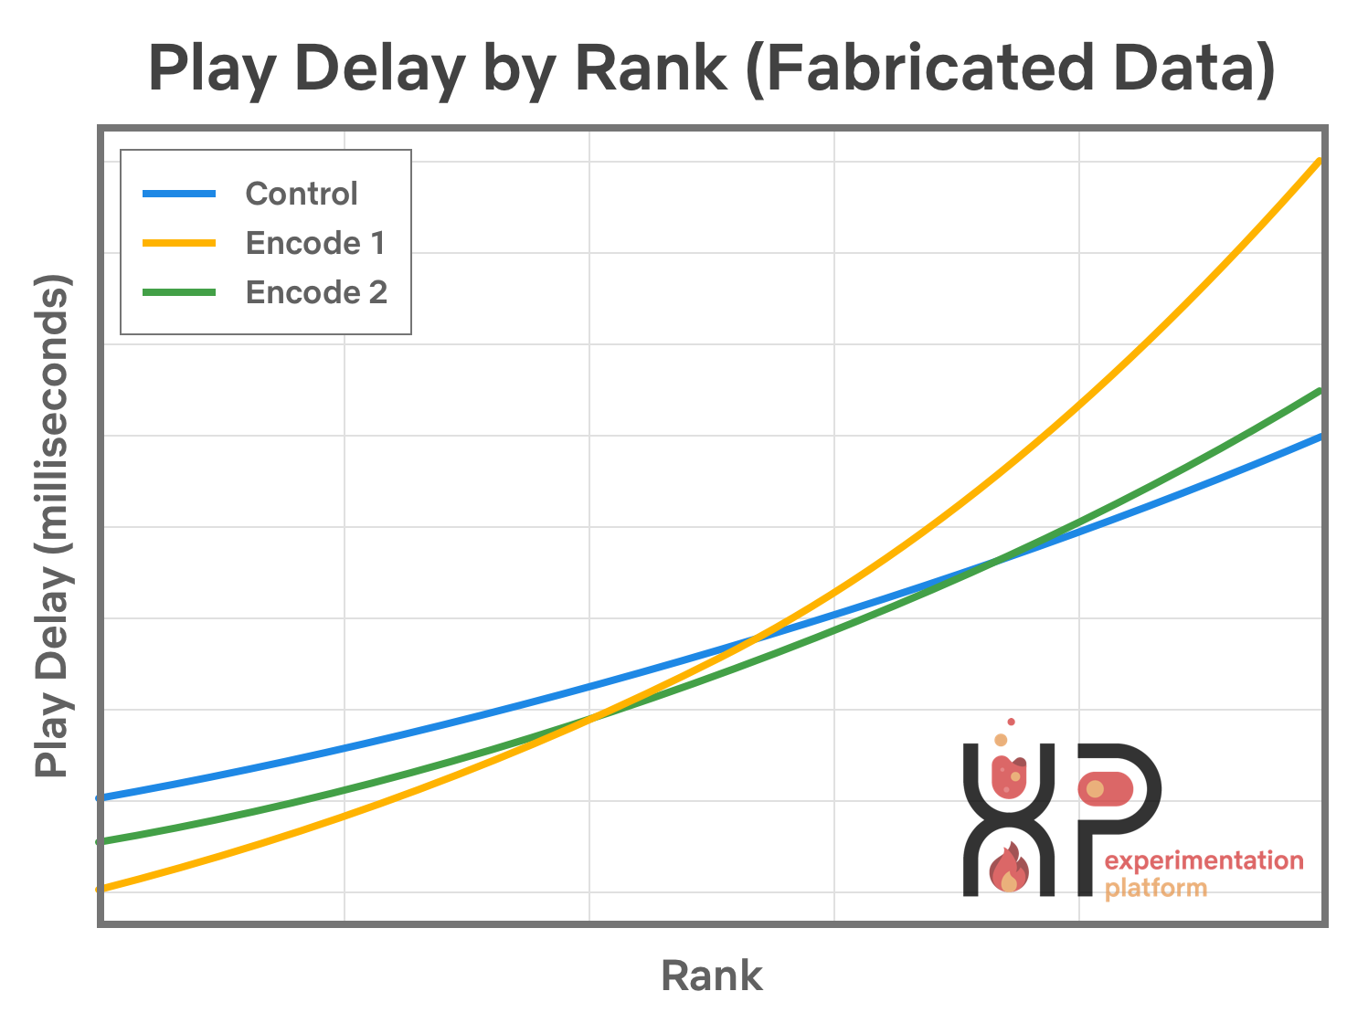

|  |
| --- |
| Simulated dataset that shows what the distribution of play delay may look like. Note that the new encodes perform well in the lower quantiles but worse in the higher ones |

## Example 2 : Title to Display

In this new experiment, all members of the explore population are in a single cell. We dynamically assign an artwork variant for every (member, title) pair just before the title gets shown to the member. In essence, we are performing the A/B test for every title with a cell for each artwork. Since the allocation happens at the title level, we are now able to accommodate different number of artwork variants per title.

This new test design allowed us to get results even faster than experiment 2 since the first N members, say 1 million, who see a title could be used to evaluate performance of its image variants. We continue to stay in explore phase as long as it takes for us to determine a significant winner — typically a few days. After that, we exploit the win and all members enjoy the benefit by seeing the winning artwork.

Here are some screenshots from the tool that we use to track relative artwork performance.

1. [***Dragons: Race to the Edge***](https://www.netflix.com/title/80039394)***:*** the two marked images below significantly outperformed all others.



Most Recent -



2. [***Unbreakable Kimmy Schmidt***](https://www.netflix.com/unbreakablekimmyschmidt)



Most Recent -



### 

### Conclusion

Over the course of this series of tests, we have found many interesting trends among the winning images as detailed in this [blog post](https://media.netflix.com/en/company-blog/the-power-of-a-picture). Images that have expressive facial emotion that conveys the tone of the title do particularly well. Our framework needs to account for the fact that winning images might be quite different in various parts of the world. Artwork featuring recognizable or polarizing characters from the title tend to do well. Selecting the best artwork has improved the Netflix product experience in material ways. We were able to help our members find and enjoy titles faster.

## Example 3 : Home Page Generation

With any algorithmic approach, choosing a good metric is important. Of fundamental importance in page generation is how to evaluate the quality of the pages produced by a specific algorithm during offline experimentation. While we ultimately will test any potential algorithmic improvement online in an A/B test, we would like to be able to focus our precious A/B testing resources on algorithms that we have evidence are likely to improve the quality of the pages. We also need to be able to tune the parameters of those algorithms before A/B testing. To do this, we can use historical data to generate hypothetical pages from new algorithmic approaches, provided we can choose a good metric for page quality.

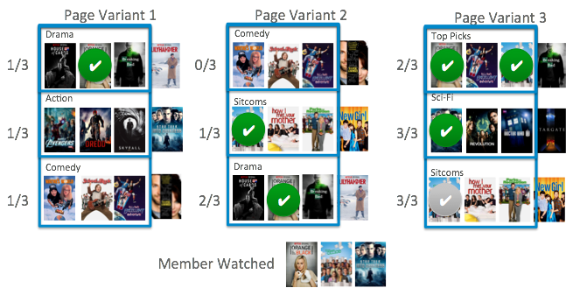

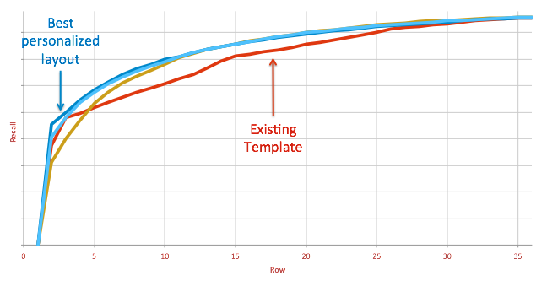

Most recent View (Laptop and Phone)-

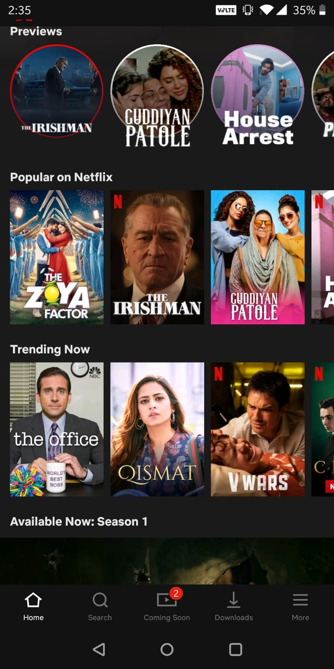

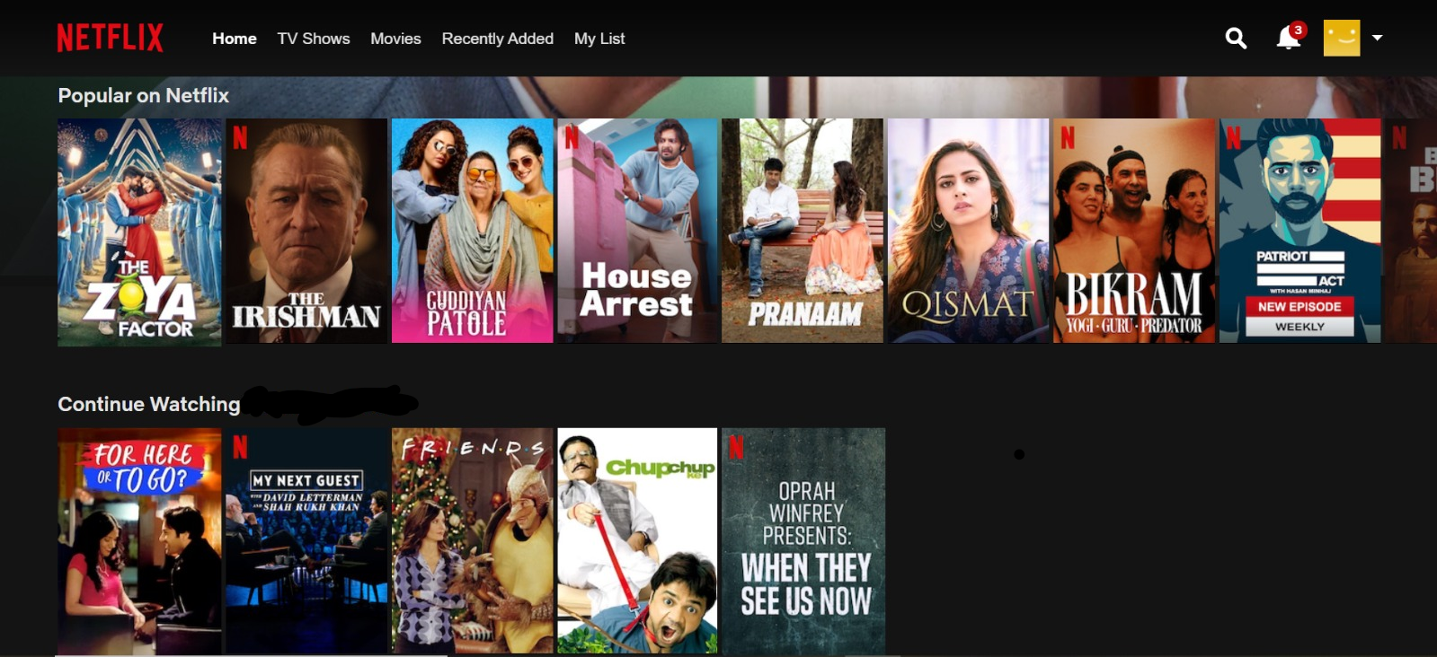



## XYZZZZZZZZZZZZZ

We’re going to focus on the results of the Progressive Web App audit.

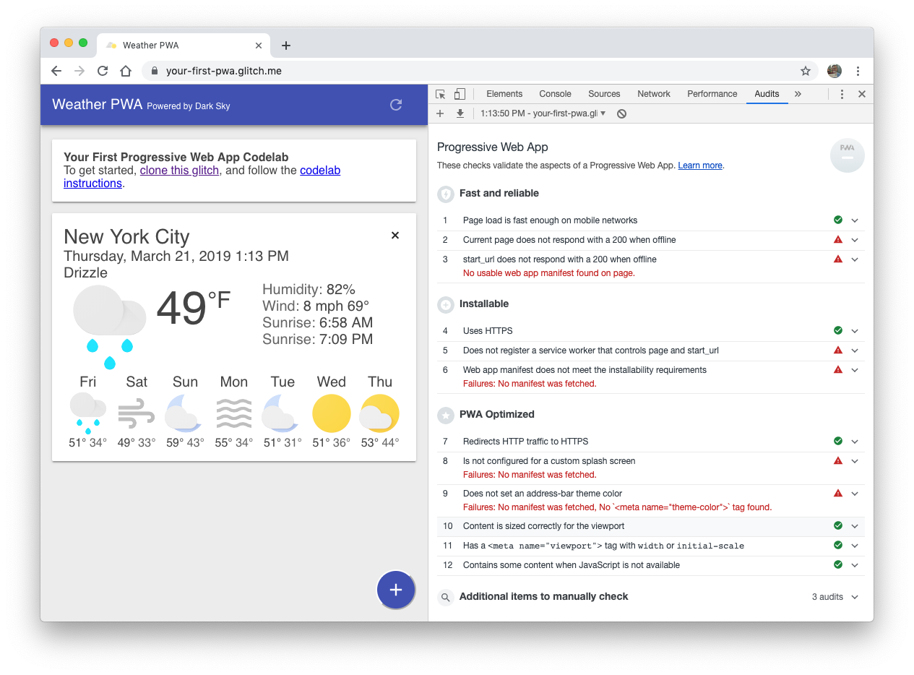

And there’s a lot of red to focus on:

* **❗FAILED:** Current page does not respond with a 200 when offline.
* **❗FAILED:** start_url does not respond with a 200 when offline.
* **❗FAILED:** Does not register a service worker that controls page and start_url.
* **❗FAILED:** Web app manifest does not meet the installability requirements.
* **❗FAILED:** Is not configured for a custom splash screen.
* **❗FAILED:** Does not set an address-bar theme color.

Let’s jump in and start fixing some of these issues!

# Reference docs

|  |
| --- |
| **References:**   * [https://www.kaggle.com/zhangluyuan/ab-testing](https://www.kaggle.com/zhangluyuan/ab-testing#ab_data.csv) * <https://www.kaggle.com/tammyrotem/ab-tests-with-python> * <https://github.com/mainkoon81/U005-project-Python-AB-testing-Comprehensive/blob/master/Analyze_ab_test_practice.ipynb> * <https://medium.com/netflix-techblog/selecting-the-best-artwork-for-videos-through-a-b-testing-f6155c4595f6> * <https://medium.com/netflix-techblog/learning-a-personalized-homepage-aa8ec670359a> * <https://medium.com/netflix-techblog/reimagining-experimentation-analysis-at-netflix-71356393af21> * <https://medium.com/netflix-techblog/its-all-a-bout-testing-the-netflix-experimentation-platform-4e1ca458c15> |